**Are there economic factors affecting the Asian Infrastructure Investment Bank (AIIB) subscriptions for its member states?**

Nikky Xiong

Data Analysis for the Social Sciences (QMSS 5015)

Professor Gregory Eirich

December 16, 2019

**INTRODUCTION**

People always assume that member states of international organizations submit subscriptions to get proportional voting power, but few people have investigated the contributors of the subscriptions. What are the economic factors that influence the amount of AIIB subscriptions for each member state? Since AIIB is such a new international organization for development, it is interesting to approach this question by running regression models with available macroeconomic data. As AIIB is a more regional-focused organization with fewer member states compared to other similar organizations like the World Bank, it is feasible to group member states into regional and non-regional members to investigate the difference. By dividing AIIB members into region and non-regional groups, we can further explore the similarities and differences in the relationship between economic factors and subscriptions.

Are there economic factors affecting the Asian Infrastructure Investment Bank (AIIB) subscriptions for its member states? If there is a statistically significant correlation between economic factors and subscriptions for AIIB members, we can examine the influencing power of economic factors on AIIB subscriptions. Significant economic factors can be used to predict the AIIB subscriptions in the future or to adjust individual member’s subscriptions accordingly. If we observe differences in the influencing economic factors for the regional and non-regional groups, we can map out each group’s pattern for their AIIB subscriptions respectively.

**DESCRIPTION OF DATA SET AND VARIABLES**

To find the relationship between economic factors and AIIB subscriptions, this study intends to regress AIIB subscriptions on the gross domestic product (GDP), GDP per capita, the growth rate of GDP, unemployment rate, average personal income, inflation rate, and foreign direct investment (FDI) for member states. Research will also introduce a controlling dummy variable to test whether there is a difference between the influencing factors of AIIB for regional members and non-regional members.

As the newest member joined AIIB in 2018 and data for economic measures are available only until 2018, this study will use data for economic measures of 2018 to have the maximum number of data to analyze.

**DESCRIPTIVE STATISTICS**



**Dependent Variable**

The dependent variable is the total amount of subscriptions for each AIIB member state. The data for AIIB subscriptions can be found on the website of AIIB, along with the country list for AIIB region members and non-regional members. **[1]** Members submitted 96,713.4 million dollars in total and in return received 1,131,737 votes. China submitted the largest amount of subscriptions of 29,780.4 million dollars, while Vanuatu submitted the smallest subscriptions with an amount of 0.5 million dollars. In return, China had the most votes of 300,215, and Vanuatu had the least voting power, with 1,816 numbers of votes.

**Independent Variables**

Data for GDP (current USD)[2], GDP per capita (current USD)[3], and the growth rate of GDP (%)[4] are available at the World Bank national accounts data and OECD National Accounts data files. The average personal income is represented by the gross national income (GNI) per capita (current USD)[5], which can also be traced at the World Bank. After joining and cleaning these datasets, there are no available data of GDP, GDP per capita, GNI per capita, for Iran.

Among the member states, China has the highest GDP of 12.14 trillion dollars, and Samoa has the lowest GDP of around 861 million dollars. Luxembourg has the highest GDP per capita of 114340.5 dollars, while Madagascar has the lowest GDP per capita of 460.8 dollars. Guinea has the fastest economic development with a GDP growth rate of 8.659%, and Sudan has the slowest economic development with a GDP growth rate of -2.321%. Switzerland has the highest GNI per capita of 83580 dollars, while Madagascar has the lowest GNI per capita of 440 dollars.

Data for the estimated total unemployment rate of the total labor force are available at the International Labor Organization, ILOSTAT database[6], and data for the annual inflation rate in percentage are available in the International Monetary Fund, International Financial Statistics and data files.[7] There are 30 missing data for the unemployment rate and 14 missing data for the inflation rate. Greece has a 19.292% unemployment rate, the highest among members with records for the unemployment rate, and Qatar has the lowest unemployment rate of 0.11%. Turkey has the highest inflation rate of 16.33%, while Ecuador has the lowest inflation rate of -0.2241%.

Data on foreign direct investment, net inflows (BoP, current US$) can be found in International Monetary Fund, Balance of Payments database, supplemented by data from the United Nations Conference on Trade and Development and official national sources.[8] China has the highest FDI amount of 2.035e+11 dollars, while the Netherlands has the lowest FDI amount of -2.393e+11 dollars.

**Controlling Variable**

There is also a dummy variable to distinguish between regional members and non-regional members of AIIB. There are 75 members of AIIB, with 44 regional members and 31 non-regional members. Region members used 73,855.3 million dollars in exchange for 836,329 votes, while non-regional members processed 295,408 votes by paying 22,858.1 million dollars.

**HYPOTHESIS**

**Hypothesis 1:** Member states who have stronger economic power and fast economic growth (higher GDP, GDP per capita, the growth rate of GDP, average personal income, inflation rate, and/or FDI), along with lower employment and inflation rate) will submit higher AIIB subscriptions.

**Hypothesis 2:** Economic factors have different influences on AIIB subscriptions for regional members and non-regional members.

**INITIAL MODELS**



As the simplest linear regression between subscriptions for AIIB members and their voting numbers results show, an increase of one vote results in an increase of 9.984e-02 million dollars in subscriptions on average, and this increase is statistically significant. Although the regression results demonstrate the statistical significance of the intercept, the intercept is not meaningful as no AIIB member will submit negative subscriptions or have zero votes.



Adding a dummy variable to control whether the member state is regional or not delivers a similar influence of voting number over subscriptions. Holding other variables constant, there will be a statistically significant increase of 9.784e-02 million dollars on average of subscriptions with every one-vote increase. Meanwhile, with every one increase in the number of votes, regional members submit 16.72 million dollars less than non-regional members on average. However, this discrepancy between regional members and non-regional members is proved to be statistically insignificant. The coefficient of the variable, *region_or_not*, is also not significant or meaningful as no member has zero votes. Since the simple linear regression shows results that are against intuitions, it is reasonable to add more potential economic influencers to test the validation of the hypothesis.



This initial linear regression model aims to observe the potential influencers of subscriptions for AIIB members. The regression results demonstrate that, holding other economic factors constant, one-vote increase leads to an average increase of 9.923e-02 million dollars in AIIB subscriptions. With every one-dollar increase in GDP, an AIIB member trends to submit 7.576e-12 million dollars more on average. As this amount is small and the difference is statistically insignificant, there is no strong supporting evidence for GDP as a critical factor for subscriptions. Similarly, with every one-dollar increase in GDP per capita, an AIIB member trends to submit 2.555e-04 million dollars more on average. As this amount is small and the difference is statistically insignificant, there is no strong supporting evidence for GDP per capita as a critical factor for subscriptions.

Other statistically insignificant economic indicators that have a relatively small negative impact on subscriptions include GNI per capita and FDI. A one-dollar increase in GNI per capita leads to an insignificant decrease of 5.997e-04 million dollars in the subscriptions on average. A one-dollar increase in FDI generates an insignificant decrease of 3.062e-11 million dollars in the subscriptions on average.

Having said that the corresponding increase in AIIB subscriptions from a one-dollar increase in GDP is insignificantly small, countries with large aggregated GDP, such as China, will submit a lot more subscriptions than countries with small aggregated GDP. Economic power determines the amount of subscriptions for AIIB to some extent. A one-percent increase in the GDP growth rate results in a 1.322-million-dollar increase in subscriptions. Although the discrepancy is proved to be statistically insignificant, it seems to be a large amount of difference that is worth noticing. Moreover, a one-percent increase in unemployment rate costs a member to pay 1.629 million dollars on average more for subscriptions, and a one-percent increase in inflation rate leads to a decrease of 9.054e-01 million dollars.



This model includes the controlling variable to see whether being a region member makes the effect of economic factors on a member’s subscriptions different. The regression result demonstrates that a regional member of AIIB submits statistically significant 3.909e-03 million dollars more subscriptions on average than a non-regional member with every one-vote increase.

While some variables, like votes and GNI per capita, have similar effects on subscriptions regardless of all being regional members or not, some variables present different influences on subscriptions. For instance, ceteris paribus, a one-dollar increase in GDP results in a statistically significant increase of 5.670e-11 million dollars in AIIB subscriptions on average.

Other variables also convey different changes on AIIB subscriptions, even though these changes remain statistically insignificant. With every one-dollar increase in GDP per capita, an AIIB member on average submits 1.729e-04 million dollars more for subscriptions. A one-percent increase in GDP growth rate saves a member on average 1.105 million dollars in subscriptions. Furthermore, every one-percent increase in the unemployment rate increases a member’s subscriptions by 0.3078 million dollars on average. A one-percent increase in the inflation rate leads to an increase of 0.2769 million dollars in subscriptions. Every one-dollar increase in FDI leads to 1.005e-11 million more dollars for subscriptions.



Based on the summary statistics, the modified linear regression model excludes the observation, Iran, and the independent variable, unemployment, as both Iran and unemployment has too many missing data that will result in biases for regression. Comparing the modified model with the initial model shown in Table 5, most variables show the same changing direction on AIIB subscriptions with a similar degree of influence. Voting number, being a regional member or not, and the member’s GDP still play a statistically significant role in affecting a member’s subscriptions.

Nevertheless, GDP per capita in this model plays a dramatically different role on subscriptions, compared to the influence in the previous model. Holding other potential variables constant, a one-percent increase in GDP per capita results in an average of 0.024e-05-million-dollar decrease in AIIB subscriptions instead of a 1.7293-04-million-dollar increase indicated by the previous model. Therefore, it is reasonable to suspect that there are confounding independent variables in the modified model.

However, does it make sense to get rid of all the statistically insignificant variables in the model altogether? To answer this question, this study further runs F tests to examine whether it is meaningful to add some of the insignificant independent variables to the final model. The results of F tests for all insignificant independent variables present that it is meaningful to add GDP, GDP per capita, and GDP growth rate to the model as the model fits better with these variables. Additional F test has performed on logged GNI per capita to see if the logged GNI per capita makes more sense. It turns out that the test fails to show supporting evidence to keep logged GNI per capita as a meaningful independent variable.

**FINAL MODEL**

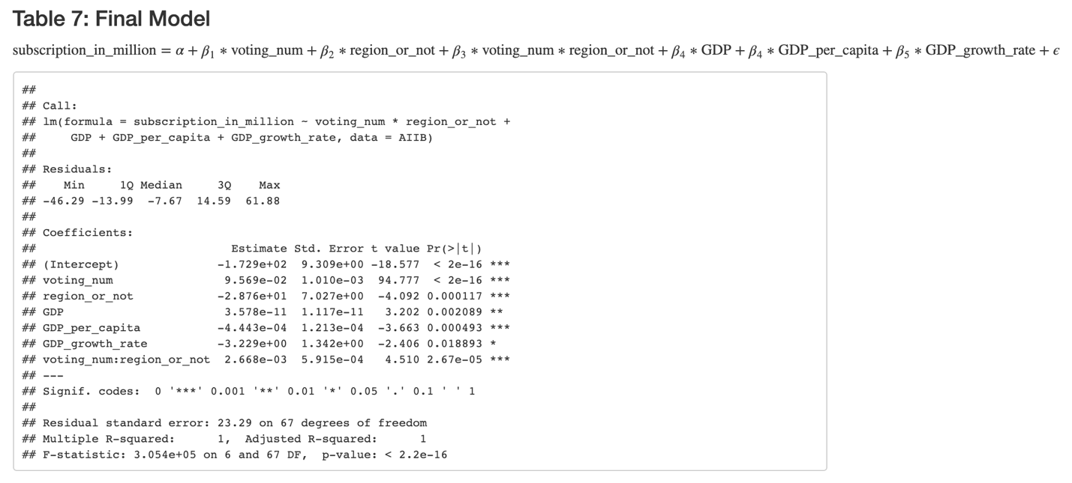

Compared with adding a logged version of GDP and GDP per capita, the original data of GDP and GDP per capita deliver more intuitive results for this study as shown above. The final linear regression model demonstrates a statistically significant correlation between AIIB subscriptions and voting number, being a regional member, the member’s GDP, GDP per capita, and GDP growth rate. Ceteris paribus, every one-vote increase generates an average 9.569e-02-million-dollar increase in AIIB subscriptions. A regional member submits 2.668e-03 million dollars more for subscriptions on average than a non-regional member, controlling other variables constant.

Holding other variables constant, for every one-dollar increase in GDP, a member submits 3.578e-11 million dollars more for subscriptions on average. One-dollar increase in GDP per capita on average decreases AIIB subscriptions by 444.3 dollars, and every one-percent increase in GDP growth rate decrease AIIB subscriptions by 3.229 million dollars.

**CONCLUSION**

Member states who have stronger aggerated economic power, shown by GDP, submit higher AIIB subscriptions, while GDP per capita and GDP growth rate shows influence in the opposite direction on subscriptions. GNI per capita does not display a statistically significant correlation with AIIB subscriptions. So do some other popular economic indicators, such as the unemployment rate, inflation rate, and FDI. Furthermore, holding other economic factors constant, a regional member of AIIB on average submits more subscriptions than a non-regional member. It is intuitive for a regional member to submit more subscriptions in exchange of more voting power to have more decision power on AIIB affairs.

Having said that GDP has a significant, positive influence on subscriptions, the degree of influence is so small that almost has zero impact if holding other significant variables constant. It is still meaningful to keep it as an independent variable as the model fits better with GDP. Although there is an inversed correlation between the growth rate of GDP and AIIB subscriptions, it is harder for large economics to have a large economic growth rate compared with smaller economic. A small percent increase for a large economy can have more economic development measured by GDP than a small economy with a larger growth rate. Therefore, the correlation between GDP growth rate and subscriptions is not entirely against the hypothesis of the study.

**LIMITATION**

The number of observations is small, so the distribution of variables might not be so normally distributed that there might be biases. The reasons behind the amount of AIIB subscriptions submitted by each member state are complicated. Further studies can be devised to investigate more influencers from political and social perspectives.

If more data are available, it will be interesting to collect panel data to see the changes in AIIB subscriptions over time. It is also meaningful to examine the effectiveness of subscriptions. For example, further study could research into whether submitting AIIB subscriptions brings proportional economic benefits back to member states.

1. https://www.aiib.org/en/about-aiib/governance/members-of-bank/index.html
2. <https://data.worldbank.org/indicator/NY.GDP.MKTP.CD?view=chart>
3. https://data.worldbank.org/indicator/NY.GDP.PCAP.CD?view=chart
4. <https://data.worldbank.org/indicator/NY.GDP.MKTP.KD.ZG?view=chart>
5. <https://data.worldbank.org/indicator/NY.GNP.PCAP.CD>
6. https://data.worldbank.org/indicator/SL.UEM.TOTL.NE.ZS
7. <https://data.worldbank.org/indicator/FP.CPI.TOTL.ZG?view=chart>
8. <https://data.worldbank.org/indicator/BX.KLT.DINV.CD.WD?view=chart>